Observed stream temperature, conductivity, and stage from the Koeye River, British Columbia between 2017 and 2021

*Methods and metadata for Koeye River sensor time-series version 1.0*

*2022-01-27*

**Introduction:**

The shortage of continuous stream temperature, conductivity, and stage data for minimally disturbed, freshwater wadeable streams impedes the analyses of long-term trends in streams data. The collection of these data will further efforts to detect and track climate change–related impacts over the long term, further our understanding of how biological, thermal, and hydrologic conditions and processes vary spatially and temporally and inter-relate to one another. This time-series was created using 5-minute average stage, water temperature, and conductivity measurements that are Quality Controlled (QC), flagged and corrected where needed (Table 2). Data gaps were filled and noisy, faulty data were corrected. These Estimated Values were assigned an ‘EV’ flag. Suspicious data points that could not be corrected and estimated were assigned an ‘SVC’ flag, for Suspicious Value – Caution. All other data points were flagged ‘AV’ for Accepted Value.

|  |  |  |  |  |
| --- | --- | --- | --- | --- |
| **Sensor Type** | **Sensor Model** | **Site and Sensor ID** | **Latitude** | **Longitude** |
| Electrical Conductivity (EC) | HOBO U24-001 | KR01_EC | 51.4633 | -127.4830 |
| Pressure Transducer (PT) deployed in water | HOBO U20L-01 | KR01_PT1 | 51.4634 | -127.4830 |
| Pressure transducer deployed to measure barometric pressure (BaroP) above water | HOBO U20L-01 | KR01_BaroP | 51.4634 | -127.4830 |
| Pressure transducer deployed to measure barometric pressure (BaroP) above water | HOBO U20L-01 | KR01_BaroP2 | 51.4634 | -127.4830 |
| Pressure Transducer (PT) deployed in water | HOBO U20L-01 | KR01_PT2 | 51.4632 | -127.4830 |

Table 1. Detailed location information for stream monitoring installations at the studied river.

Methods:

**Study Area Description**

The Koeye River drains a 171 km2 coastal watershed located on the mainland coast of British Columbia adjacent to Fitz Hugh Sound. The watershed ranges from a maximum elevation of 1304 m to sea-level. The climate is characterized by ocean-moderated temperatures, and heavy precipitation – primarily as rain – that increases with elevation. A seasonal snowpack is found at higher elevations. The vegetation is temperate rainforest and a large lake occupies a mid-catchment position (Housty et al., 2014). The watershed has long been used by the Indigenous people yet is largely unimpacted by industrial activities and continues to support significant salmon and grizzly bear populations (Housty et al., 2014; Atlas et al., 2017). However, climate change may impact salmon survival in this watershed via alterations to streamflow and stream temperature (Atlas et al., 2021).

**Site Selection and Sensor Installation**

Sensors were installed in 2017 after using several reconnaissance trips and local knowledge to select a site that is suitable for gauging and for monitoring river water quality, representative of the watershed outlet to the ocean. This required finding a site that is upstream of tidal influences on river stage or chemistry (salinity). We conducted multiple reconnaissance walks of the lower reach, consulted with local knowledge holders, and measured electrical conductivity at numerous locations between the estuary and freshwater. Hydrologists Dr. William Floyd and Maartje Korver evaluated site suitability for gauging. Dr. Will Atlas and William Housty shared their prior knowledge of tidal influence on the lower reaches. The lower river has a low gradient and thus tidal influences far up from the large obviously estuarine areas. Options for gauging locations are limited due to either channel geometry (upstream) or tidal influences (downstream). The best available site was selected, just above the zone of regular tidal influence. Subsequent monitoring of the site shows rare occasions of saltwater apparently reaching the station, potentially due to a combination of very high tide and low flow.

Both the stream stage (HOBO U20L-01) and conductivity (HOBO U24-001) sensors are mounted in separate installations that are side-by-side on river left, inside double-walled instrument housing, comprised of a PVC inner tube and surrounded by a rigid metal box-tube (Telespar). The housing is rigidly attached to exposed bedrock with metal strapping and anchor bolts (Figure 1). Atmospheric pressure (HOBO U20L-01) is measured directly across the river, on river right, and the sensor is housed in a 1.5 m length of slotted PVC pipe inserted 1 m into the ground (Figure 2).

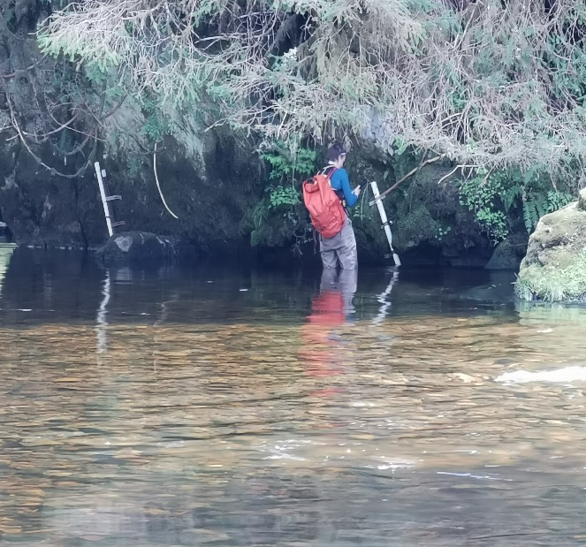 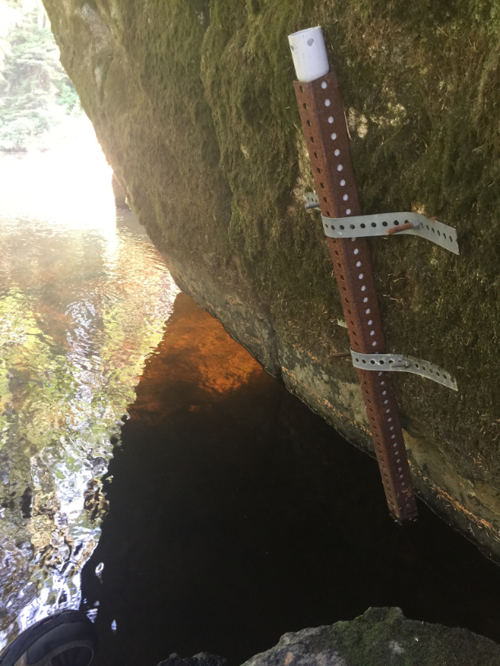

Figure 1. Sensors located on river left with water level sensor 2m upstream (left) of the conductivity sensor (right).

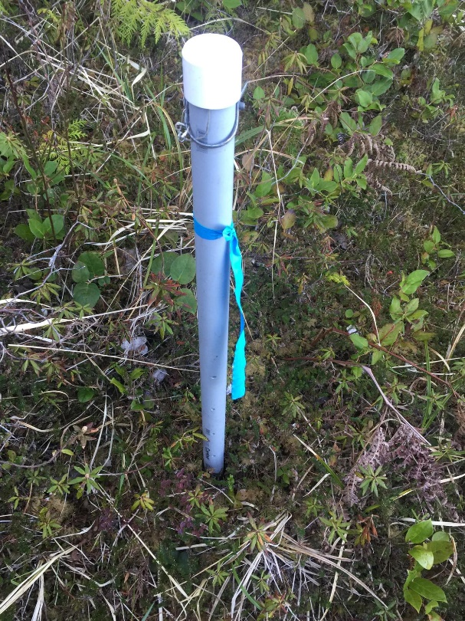

Figure 2. Barometric pressure sensor in PVC housing 3 m inland on river right.

**Data Downloads and Quality Control**

The stream stage, conductivity and temperature time-series data package was created using 5-minute average measurements that are quality controlled (QC’d), flagged and corrected where needed (Table 2) according to the steps outlined in the “[Hakai Sensor Network Quality Control (QC)](https://docs.google.com/document/d/1mDZrPlHqRUK-L4An4eW3m_hvu2nfsXA7TdNZ2s6-JCw/edit)” document. A general summary of the QC process is outlined in the steps below:

1. Download annual data
2. Check for outliers:
   * Generate scatter plots illustrating temporal standard deviation (SD) distribution and stream temperature
   * Investigate instances where SD differs substantially relative to the spread of the data
   * Assess/determine whether to accept or reject value
3. Check for prevalence of automated flags
   * Assess/determine whether to accept or reject
4. Range
   * Confirm data fall within realistic upper and lower bounds (i.e typically no sub-zero temperatures in summer months depending on elevation of site)
5. Persistence
   * Is there a repeated value indicative of a sensor malfunction?
6. Internal consistency
   * Are values realistic for a given time period? (i.e does water temperature fluctuate diurnally?)
7. Spatial consistency
   * Are data patterns consistent with what networked sensors in the same area recorded?
8. Manual gap-filling
   * Use linear regression to establish relationship between two sensors and compute missing values for gap-filling
9. Assign flags to remaining data in accordance with “[Hakai Sensor Network Quality Control (QC)](https://docs.google.com/document/d/1mDZrPlHqRUK-L4An4eW3m_hvu2nfsXA7TdNZ2s6-JCw/edit)” document
10. Re-upload to Sensor Network QC portal

Summary and Examples of Commonly Assigned Flags:

SVD- Suspicious Value Delete

* Unrealistically high or low values
* Obvious sensor malfunction
* People on site
* Abrupt changes that can’t be explained by natural mechanisms
* Sensor removed for download

SVC- Suspicious Value Caution

* Value outside normal range observed
* Possible natural phenomenon
* Sensor may have been malfunctioning but it is uncertain

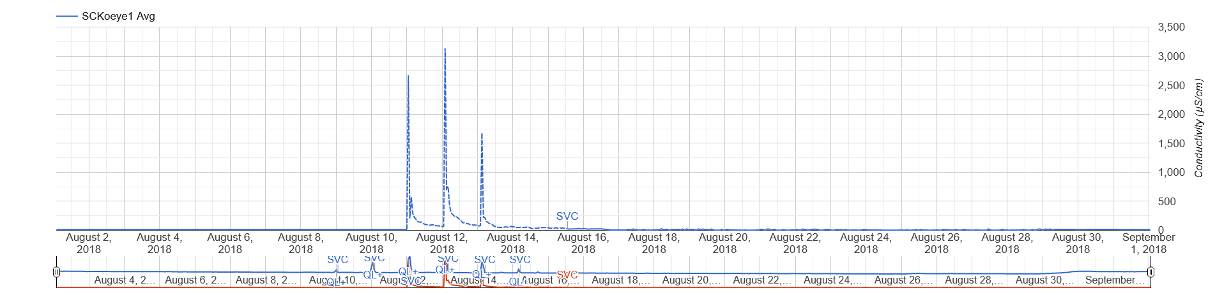

*Figure 1: Instance of* ***Suspicious Value Caution*** *flagging at KR01 EC, likely attributed to tidal influence.*

EV - Estimated Value

* EV from manual gap-filling

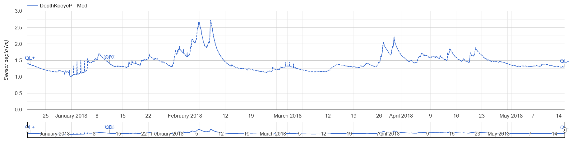

*Figure 2: Example of* ***Estimated Value*** *flagging. This example highlights a time period where water level data was estimated due to a failing barometric pressure sensor.*

Summary of QAQC Results

The following tables provide a summary of the quality flags assigned (Table 2) in addition to an overview of the major issues experienced at each site (Table 3).

Table 2: Flag allocation per variable 2020-06-14 to 2021-10-22. For access to the provisional data and the interactive online tool, please email data@hakai.org.

|  |  |  |  |  |  |  |  |
| --- | --- | --- | --- | --- | --- | --- | --- |
| **Variable name** | **Measurement** | **AV** | **SVD** | **SVC** | **MV** | **EV** | **Total** |
| [DepthKoeyePT2](https://hecate.hakai.org/sn/p/viewsndata.pl?dataTable=1hourSamples&measurements=SA_KR01_PT2.SensorDepth_Med) | Water Depth | 21682 |  | 1915 |  |  | **23597** |
| [TwtrKoeyePT2](https://hecate.hakai.org/sn/p/viewsndata.pl?dataTable=1hourSamples&measurements=SA_KR01_PT2.WaterTemp_Avg) | Temperature | 23739 |  |  |  |  | **23739** |

Table : Summary of major issues of note at specific sites.

|  |  |  |  |
| --- | --- | --- | --- |
| **Site** | **Issue** | **Action** | **Link** |
| BaroPKoeye1 | -Sensor frozen ~Dec 2017 data compromised intermittently | * Sensor replaced with BaroP2Koeye July 2018 * Barometric compensation for affected periods computed using relationship with nearby met station pressure |  |
| DepthKoeyePT | -Sensor stuck inside installation due to freezing/sediment buildup Jan 2018  -Sensor and installation removed May 2018  -Re-installed for overlap with PT2 July 2018  -Sensor moved vertically 26.2 cm after re-installation  -Uninstalled October 2018 | * Corrected for 26.2cm movement   + Flagged as **EV** | [PT1](https://hecate.hakai.org/sn/p/viewsndata.pl?dataTable=5minuteSamples&measurements=SA_KR01_PT.SensorDepth_Avg&firstMeasurementTime=2018-05-04%2005:31&lastMeasurementTime=2018-07-30%2013:12) |
| DepthKoeyePT2 | -Installed May 2018 | * Backfilled PT2 data to the start of the dataset using a regression between PT1 and PT2 data   + June 2017 to Sept 2018   + Flagged as **EV** | [PT2](https://hecate.hakai.org/sn/p/viewsndata.pl?dataTable=5minuteSamples&measurements=SA_KR01_PT2.SensorDepth_Avg) |
| SCKoeye1 | -Large tidal event Aug 2018 data affected | * Data kept as spikes are likely due to tidal influence   + Flagged as **SVC** | [SC](https://hecate.hakai.org/sn/p/viewsndata.pl?dataTable=5minuteSamples&measurements=SA_KR01_PT2.SensorDepth_Avg,SA_KR01_EC.SpecificConductance_Avg&dateRange=2018-08) |

Data Summary

Water Temperature (°C)

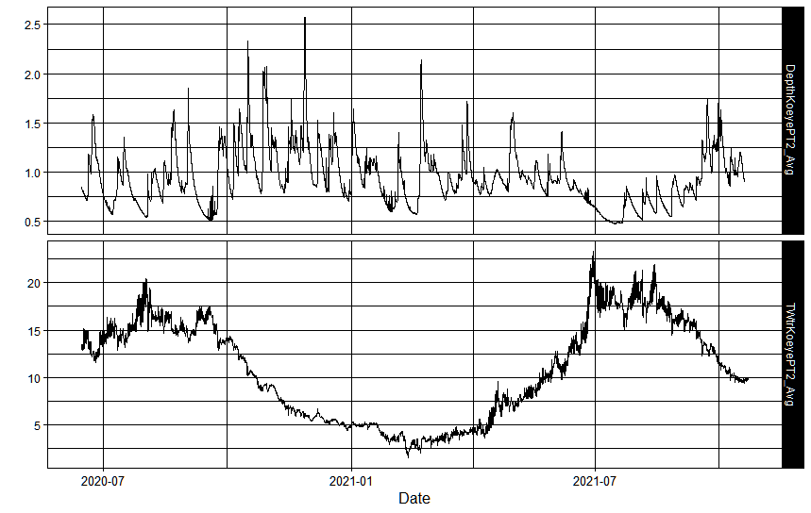

Water Level (m)

Figure 3. Time series for Koeye PT2 water level and temperature.

Data Access

All the data and metadata corresponding to this report have been published to an open data repository. The data package includes 5-minute stream data from 2017 to 2020. For data access please see:

‘Koeye River time-series v2_2020 to 2021.’ Hakai Institute Data Package. DOI: (insert here)

Contact Ian@hakai.org or data@hakai.org for more information about data access and opportunities to collaborate.

Acknowledgements

The sensor installation and operation described here is done with permission of, and in consultation with, Heiltsuk Nation and BC Parks. We thank Larry Jorgensen, William Housty, Jess Housty, and Kelly Brown for guidance working in this important area of Heiltsuk territory. We thank Bill Floyd, Maartje Korver, and Will Atlas, for assisting with the original design. For significant contributions in the field we thank Ben Millard-Martin, Isabelle Desmarais, and Rob White.

References

Atlas, W. I., Housty, W. G., Béliveau, A., DeRoy, B., Callegari, G., Reid, M., & Moore, J. W. (2017). Ancient fish weir technology for modern stewardship: lessons from community-based salmon monitoring. *Ecosystem Health and Sustainability*, *3*(6). <https://doi.org/10.1080/20964129.2017.1341284>

Atlas, W. I., Seitz, K. M., Jorgenson, J. W. N., Millard-Martin, B., Housty, W. G., Ramos-Espinoza, D., … Moore, J. W. (2021). Thermal sensitivity and flow-mediated migratory delays drive climate risk for coastal sockeye salmon. *Facets*, *6*(1), 71–89. <https://doi.org/10.1139/facets-2020-0027>

Housty, W. G., Noson, A., Scoville, G. W., Boulanger, J., Jeo, R. M., Darimont, C. T., & Filardi, C. E. (2014). Grizzly bear monitoring by the Heiltsuk people as a crucible for First Nation conservation practice. *Ecology and Society*, *19*(2). <https://doi.org/10.5751/ES-06668-190270>

Appendix

The barometric pressure sensor began intermittently malfunctioning in December 2017 likely caused due to ice build-up in the PVC housing. A second sensor (Koeye StnPres) was regressed with Koeye BaroP to develop a linear relationship (Figure 6) between the two sensors during overlapping periods when Koeye BaroP was functioning as expected (Figure 7). This relationship was used to gap-fill periods Koeye BaroP data was obviously bad. Koeye BaroP2 was installed in July 2018 to replace Koeye BaroP.

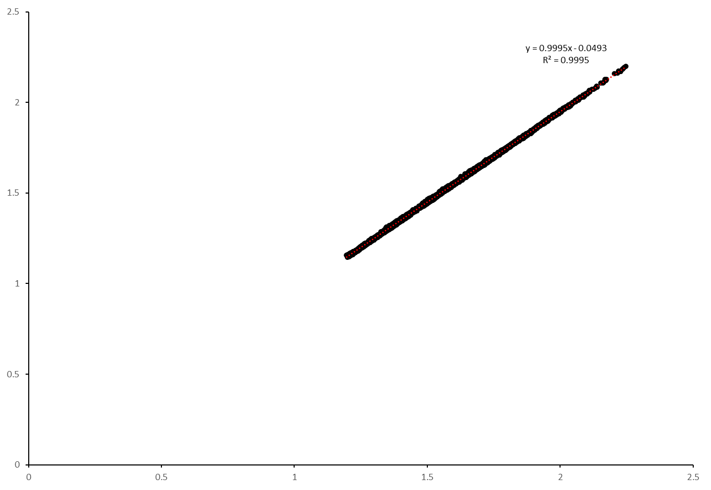

Figure 6) Scatterplot illustrating relationship between the Koeye BaroP sensor and Koeye Stn Pres sensor. This relationship was used to gap-fill bad Koeye BaroP data. This data was then used for barometric compensation to derive the DepthKoeyePT water level time-series.

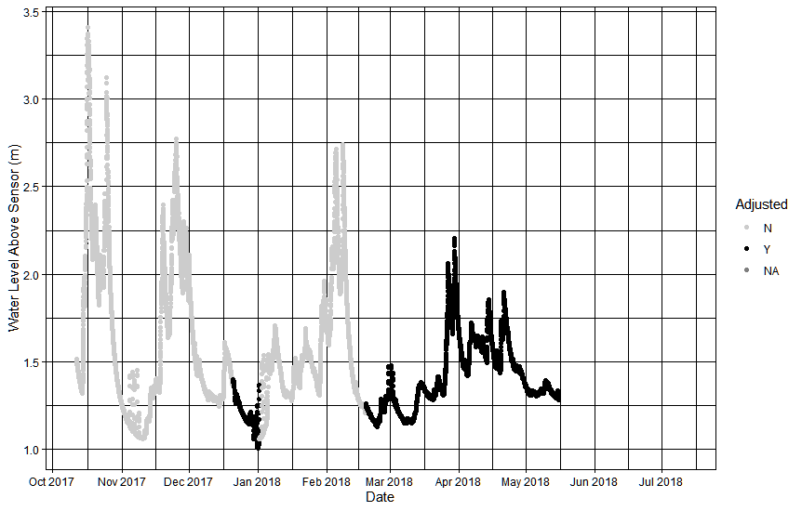

Figure 7) Scatterplot illustrating Koeye PT time-series. The series is colour coded to illustrate where barometric compensation was computed using the relationship between Koeye PT and KoeyeStnPres.